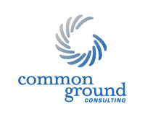

Program Logic Model

Inputs

Outputs

Activities Participants
Outcomes — Impact

Short Term Medium Term Long Term

Priorities

What We Do:

Who We Reach:

What Are The Short Term Results:
(Learning)

What Are The Mid Term Results:
(Action)

What Are The Desired Ultimate Impacts:
(Social or Policy Change)

Situation

What We Invest:

Assumptions

External Factors

